**Knowledge Discovery & Management LAB-2**

**V.Y.V.AKHILESH 16165666.**

*I have created an android mobile application which shows the current weather condition of the city .

*For this first i created an application page and it consists of box where we need to type or enter the city name for which we want the weather for, and then tap on the submit button.

*In order to make this application to work or to fetch the details of weather i used weather api's.

*After tapping on the submit button it will fetch the current weather conditions of the city which we have entered

*The screen shots of working of the application and the coding are shown below.

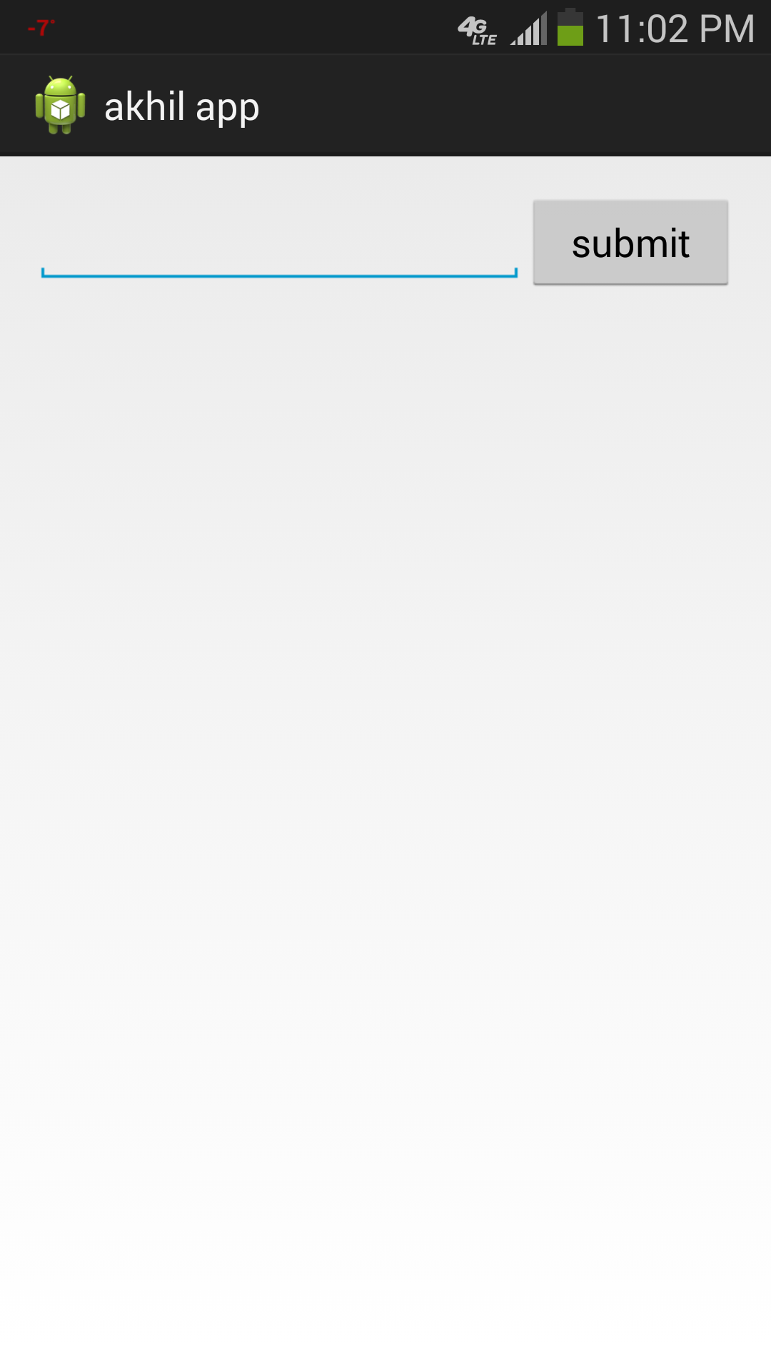  
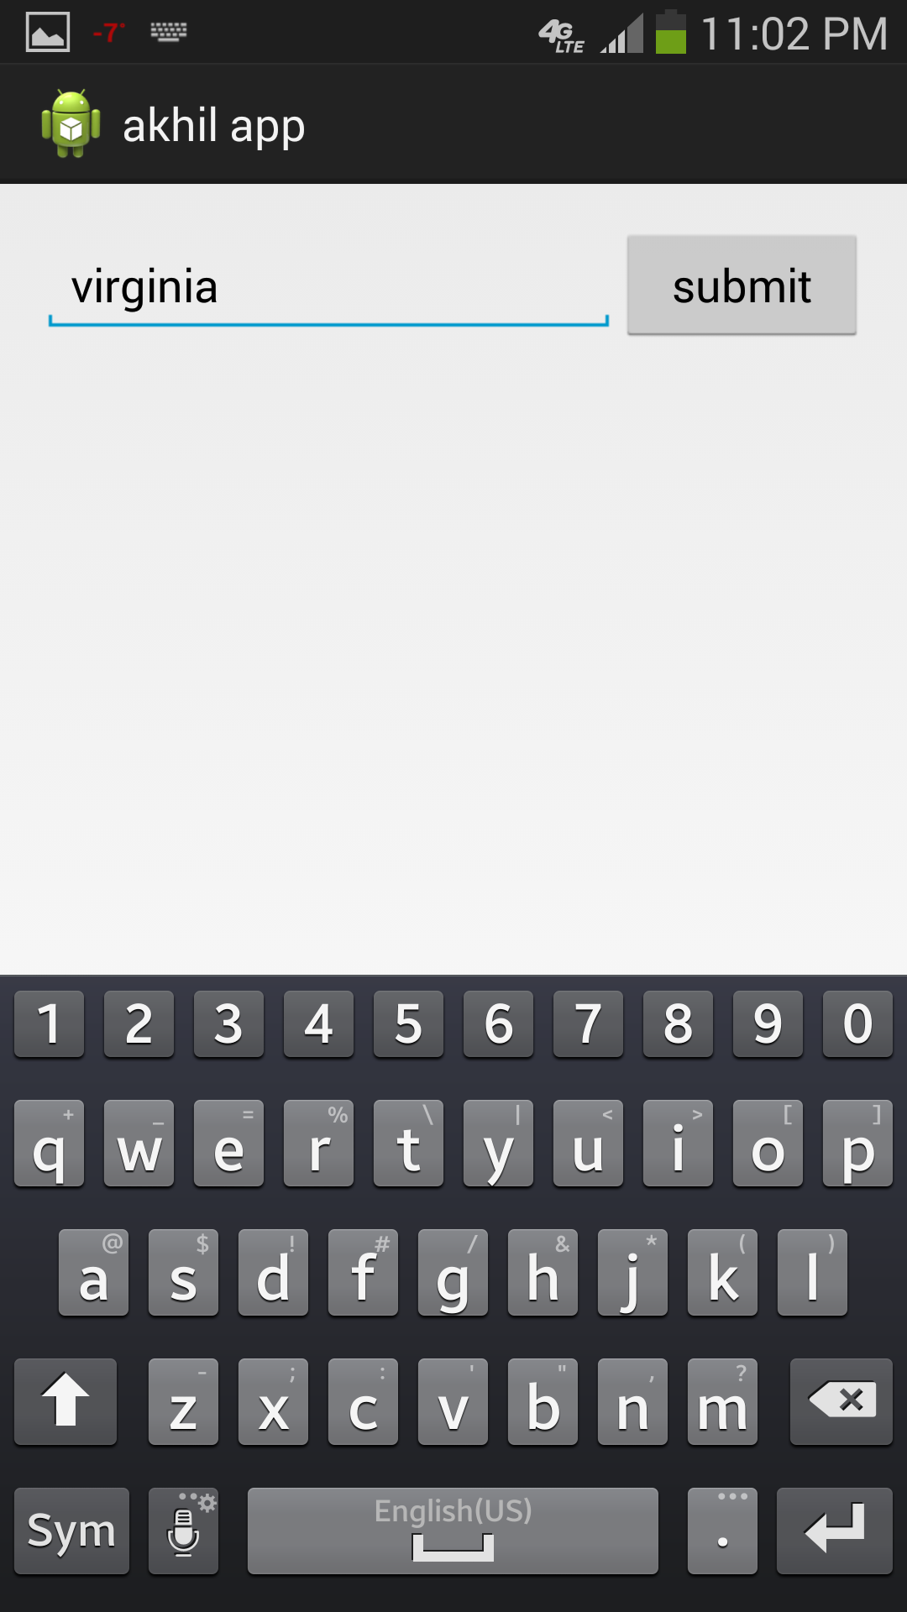  
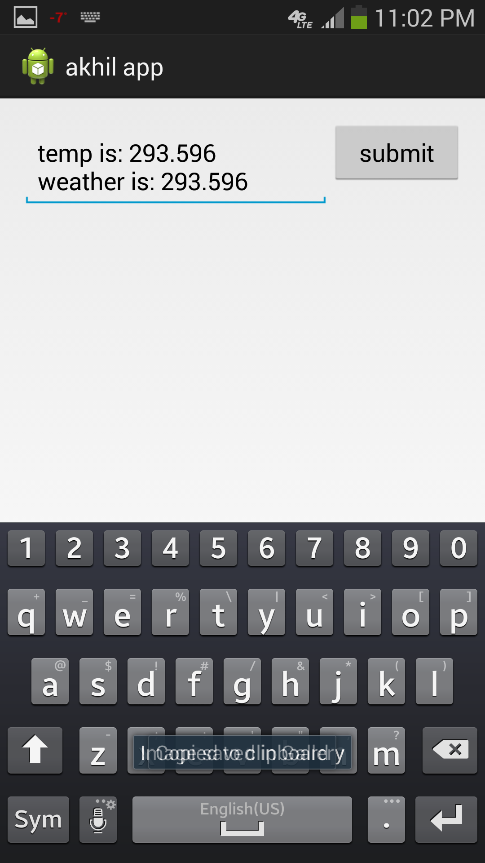

Screen shot of activity_main.xml

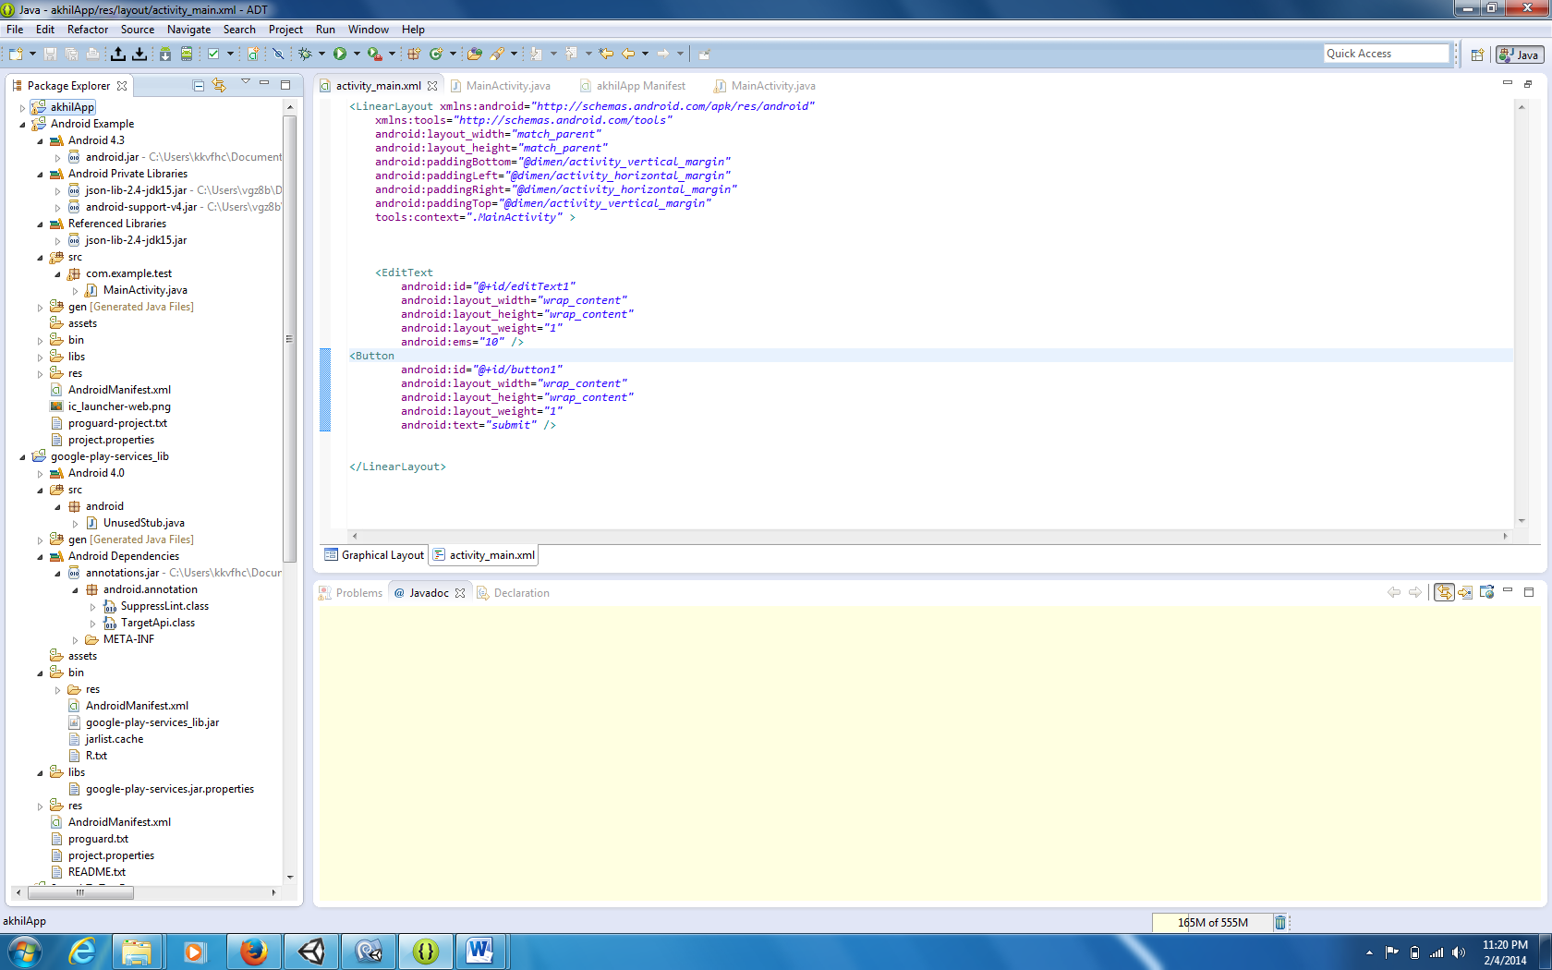

Screen shot of mainactivity.java

